Data Analytics Capstone:
Analysis of Facility and Unit Attributes under the EPA Clean Air Markets Program Using Statistical and Machine Learning Techniques
Interim Capstone Report
Dhananjay Verma
Student ID: 0291493
Division of Mathematics and Computer Science
Walsh College, Troy, MI
QM640 V1: Data Analytics Capstone
Faculty Mentor: Dr. Javad Katibai
Summer 2026 Term
October 15, 2026

Executive Summary & Project Repository
This Interim Capstone Report is submitted as a standalone academic document in partial fulfillment of the requirements for the Master of Science in Data Analytics and Artificial Intelligence at Walsh College. In accordance with the academic curriculum guidelines of QM640 V1, this report provides an autonomous, self-contained evaluation of the research design, empirical data cleaning, exploratory data analysis (EDA), statistical hypothesis testing, and preliminary machine learning modeling conducted on electric power generating facilities regulated under the United States Environmental Protection Agency (EPA) Clean Air Markets Program (CAMP).
GitHub Data Availability Statement
To support scientific reproducibility, public auditability, and academic evaluation, all raw data artifacts, engineered datasets, executable Jupyter Notebook (.ipynb), Python modeling scripts, statistical pipelines, and visualization routines have been systematically curated and deposited in the official project repository:
Project Repository: https://github.com/djmsritai-tech/QM640-Data-Analytics-Capstone
Raw data: https://github.com/djmsritai-tech/QM640-Data-Analytics-Capstone/blob/main/data/raw/facility-2025.csv
Processed/clean data: https://github.com/djmsritai-tech/QM640-Data-Analytics-Capstone/blob/main/data/processed/facility_clean_processed.csv
Code/notebooks: https://github.com/djmsritai-tech/QM640-Data-Analytics-Capstone/tree/main/scripts (and https://github.com/djmsritai-tech/QM640-Data-Analytics-Capstone/blob/main/QM640_Capstone_Analytics_Notebook_DhananjayVerma_0291493.ipynb)
Figure Directory: outputs/figures/ (11 APA 7 publication-grade figures at 300 DPI)
Academic Standing Declaration: Standalone Academic Notice: While this Interim Report logically succeeds the initial Capstone Synopsis submitted in the Winter term, no prior dependency or external knowledge of the synopsis is required. A reader, evaluator, or regulatory auditor can comprehensively evaluate the theoretical foundation, analytical methodology, empirical results, and strategic implications from this standalone document alone.
1. Introduction
Background and Context
Atmospheric pollution originating from stationary combustion sources constitutes one of the most critical public health and environmental challenges of the modern industrial era. Electric power generation facilities—primarily those combusting fossil fuels including bituminous coal, sub-bituminous coal, pipeline natural gas, and residual fuel oils—are major point sources of criteria air pollutants. These combustion processes emit substantial quantities of sulfur dioxide (SO₂), nitrogen oxides (NOₓ), hazardous air pollutants such as mercury (Hg), and primary particulate matter (PM₂.₅ and PM₁₀). Epidemiological and economic studies have repeatedly demonstrated that ambient exposure to fine particulates and ground-level ozone causes severe cardiorespiratory illnesses, premature mortality, and regional ecological acidification (Harrington et al., 2004; Burtraw et al., 2012).
To curtail stationary source emissions, the United States Environmental Protection Agency (EPA) established market-based regulatory frameworks under the Clean Air Act Amendments of 1990. These initiatives encompass the Acid Rain Program (ARP), the Clean Air Interstate Rule (CAIR), the Cross-State Air Pollution Rule (CSAPR, including CSNOX and CSSO2G2), and the Mercury and Air Toxics Standards (MATS). Central to these market-oriented programs is the Clean Air Markets Program (CAMP), which couples statutory emission allowance trading with rigorous, continuous emission monitoring systems (CEMS) mandated under 40 CFR Part 75 (U.S. EPA, 2024). Under this regime, the EPA collects and publishes unit-level data capturing thermal capacities, primary and secondary fuel choices, boiler architectural configurations, and pollution abatement controls.
The operational setting of this research is the contemporary U.S. bulk power system during the calendar year 2025. The electric power sector is currently undergoing a structural transformation characterized by the rapid retirement of legacy coal-fired generating units, increased utilization of high-efficiency natural gas combined cycle (NGCC) plants, the deployment of fast-ramping combustion turbines for renewable intermittency balancing, and the impending enforcement of stricter environmental regulations (Ellis et al., 2019; Schmalensee & Stavins, 2017). Within this setting, primary stakeholders include federal environmental regulators (EPA program administrators), regional transmission organizations (RTOs and ISOs), state environmental protection agencies, electric utility asset managers, and ESG investment analysts who require quantitative, data-driven models to benchmark emission compliance risk and project fleet transition trajectories.
Problem Statement
Despite decades of standardized environmental regulations and mandatory reporting under the Clean Air Markets Program, operational thermal capacity and potential emission rates exhibit pronounced heterogeneity across the national generating fleet. Existing compliance frameworks frequently treat generating units as homogeneous technological entities within broad fuel categories, overlooking complex multidimensional interactions among boiler vintage, unit age, installed generation capacity, pollution control architectures, and regional regulatory enforcement. The absence of scalable, data-driven predictive and segmentation models limits the ability of environmental regulators to anticipate high-emission non-compliance risks proactively and impedes power plant operators from establishing empirical benchmarks for unit retrofitting or retirement. This research addresses this gap by synthesizing statistical inferential modeling with supervised and unsupervised machine learning to explain, predict, and segment facility-level operational intensity and compliance risk.
Purpose of the Study
The primary purpose of this quantitative empirical study is fourfold: (a) to evaluate whether facility attributes—specifically primary fuel classification and boiler design—exert statistically significant effects on maximum hourly heat input rate and emission capacity; (b) to construct and validate supervised classification algorithms capable of predicting high-emission generating units based on operational features; (c) to assess the linear and non-linear bivariate and multivariate relationships between generating unit vintage (age) and thermal operational intensity; and (d) to formulate an unsupervised clustering framework that segments the U.S. power generation fleet into distinct, interpretable operational and emission-risk archetypes.
Interim Project Status (Progress Snapshot)
A structured summary of completed, in-progress, and pending milestones is outlined below:
Completed: Data acquisition from EPA CAMPD bulk repository (N = 4,050 records, 30 variables); data cleaning pipeline; imputation strategy; duplicate validation; feature engineering of Unit Age, Capacity (MWe), Heat Input Rate, and Pollution Control counts; exploratory data analysis; statistical testing for RQ1 (ANOVA, Kruskal-Wallis, Tukey HSD); exploratory scatter and correlation matrices.
In Progress: Supervised machine learning model training and hyperparameter optimization (Logistic Regression, Random Forest, Gradient Boosting) for RQ2; OLS simple and multivariate regression modeling for RQ3; K-Means unsupervised clustering, Elbow WCSS optimization, Silhouette coefficient evaluation, and 2D Principal Component Analysis (PCA) for RQ4.
Pending: Longitudinal panel data expansion incorporating 2020-2024 historical CEMS hourly emissions; integration of state-level ambient air quality monitoring stations; deployment of SHAP (Shapley Additive exPlanations) values for global/local machine learning interpretability; formulation of prescriptive policy and retrofitting guidelines for the final capstone deliverable.
Scope and Objectives
The spatial scope of this investigation encompasses all stationary electric utility and industrial power generating units located in the 50 U.S. states, the District of Columbia, and associated territories reporting under the EPA Clean Air Markets Program for the 2025 reporting period. The temporal scope focuses on cross-sectional operational attributes registered as of 2025. The study explicitly focuses on operational combustion parameters, installed capacity, pollution abatement equipment, and regulatory classifications. Detailed dispersion plume modeling, downstream meteorological transport simulations, human health epidemiological impact modeling, and corporate balance sheet financial accounting fall outside the immediate scope of this empirical investigation.
Research Questions and Hypotheses
To provide rigorous quantitative resolution to the problem statement, four formal research questions (RQs) and associated statistical hypotheses are investigated:
Research Question 1 (RQ1): Emission & Thermal Load Variability across Fuels
Do facility attributes, specifically primary fuel category and unit technology type, significantly influence maximum hourly heat input rates and operational combustion capacity across the U.S. power fleet?
H0: Null Hypothesis (H0): There is no statistically significant difference in mean or median maximum hourly heat input rates across primary fuel categories (μ_Coal = μ_Gas = μ_Oil = μ_Biomass).
H1: Alternative Hypothesis (H1): Maximum hourly heat input rates differ significantly across primary fuel categories, with fossil solid fuels exhibiting systematically higher combustion capacities.
Analytical Formulation: Statistical Model: Heat_Input_Rate_ij = μ + α_i (Fuel_Category) + ε_ij, evaluated via One-Way Analysis of Variance (ANOVA) and non-parametric Kruskal-Wallis H-testing.
Research Question 2 (RQ2): Predictive Classification of High-Emission Units
Can facility and unit operational attributes (installed capacity, boiler vintage, pollution control count, and regional location) accurately classify and predict high-emission generating units (defined as units operating in the upper quartile, ≥ 75th percentile of national maximum hourly heat input capacity)?
H0: Null Hypothesis (H0): Operational and technological attributes possess no predictive power (AUC ≤ 0.50, F1-score equal to random guessing) in classifying high-emission generating units.
H1: Alternative Hypothesis (H1): Machine learning classifiers trained on unit attributes can predict high-emission facilities with superior discriminative performance (ROC-AUC ≥ 0.90, F1-score ≥ 0.80).
Analytical Formulation: Model Specifications: Regularized Logistic Regression, Random Forest Ensembles (MDI Gini splitting), and Gradient Boosting Classifiers evaluated via 5-fold stratified cross-validation.
Research Question 3 (RQ3): Unit Age and Operational Intensity Dynamics
What is the empirical nature, magnitude, and statistical significance of the relationship between generating unit age (vintage) and maximum thermal heat input capacity?
H0: Null Hypothesis (H0): There is no statistically significant linear or monotonic relationship between generating unit age and maximum hourly heat input rate (β_Age = 0; Pearson r = 0; Spearman ρ = 0).
H1: Alternative Hypothesis (H1): A statistically significant positive relationship exists between unit age and thermal heat input rate (β_Age > 0), reflecting the larger combustion volume of legacy baseload steam facilities.
Model Equations: Analytical Formulation: Bivariate Ordinary Least Squares (OLS): Heat_Input = β0 + β1(Age) + ε; Multivariate OLS: Heat_Input = β0 + β1(Age) + β2(Capacity_MW) + β3(Control_Count) + ε.
Research Question 4 (RQ4): Unsupervised Operational Segmentation & Archetypes
Can the heterogeneous national generating fleet be partitioned into distinct, objectively validated operational clusters based on continuous attributes of capacity, thermal input, unit age, and pollution control adoption?
H0: Null Hypothesis (H0): Power generation units form a continuous, undifferentiated operational distribution with no identifiable, cohesive clustering structure (Silhouette score ≤ 0.20).
H1: Alternative Hypothesis (H1): Generating facilities naturally cluster into distinct, interpretable operational archetypes exhibiting substantial between-cluster separation and within-cluster cohesion.
Clustering Framework: Analytical Formulation: K-Means clustering across standardized multidimensional space; cluster count selection via Within-Cluster Sum of Squares (Inertia Elbow) and Silhouette coefficient optimization; 2D projection via Principal Component Analysis (PCA).
2. Literature Survey
Literature Review Approach
A systematic literature review was conducted to synthesize empirical methodologies, economic theories, and environmental engineering principles relevant to facility-level emissions, air pollution regulatory compliance, and machine learning applications in energy systems. Electronic databases queried included IEEE Xplore, ScienceDirect, Elsevier Energy Policy, SpringerLink, JSTOR, and Google Scholar. The query syntax utilized Boolean logic: ('Clean Air Markets Program' OR 'Acid Rain Program' OR 'CAMPD') AND ('facility attributes' OR 'boiler vintage' OR 'heat input') AND ('machine learning' OR 'clustering' OR 'classification' OR 'ANOVA').
Inclusion criteria required peer-reviewed journal articles, foundational statistical texts, or authoritative government reports published between 1952 and 2024 that addressed stationary combustion sources, environmental policy instruments, non-parametric hypothesis testing, regression diagnostics, or industrial clustering. Theoretical publications lacking empirical grounding or studies restricted entirely to mobile vehicular emissions were excluded. A total of 14 seminal sources were identified and synthesized.
Summary of Key Literature
The 14 foundational sources are itemized in Table 1, summarizing author credentials, publication year, operational domain, underlying datasets, analytical methods, empirical findings, and direct linkage to the research questions investigated in this capstone.
Table 1
Literature Relevance Matrix
Author (Year) | Domain/Context | Dataset/Setting | Method(s) | Key Findings | Linkage to RQs
U.S. EPA (2024) | Environmental Regulation | EPA CAMPD Bulk Files (2024-2025) | Continuous Emission Monitoring (CEMS), 40 CFR 75 | Transparency in reporting drives compliance; fuel and boiler design govern baseline emissions. | Provides raw data schema, unit-level dictionary, and regulatory baseline for RQ1-RQ4.
Ellis et al. (2019) | Energy & Environmental Policy | U.S. Power Plant Panel (2000-2016) | Fixed Effects Econometrics, Panel Regression | Market-based programs induced massive fuel switching from coal to natural gas, reducing SO2 by >80%. | Supports fuel category grouping (RQ1) and feature selection for predictive classification (RQ2).
Schmalensee & Stavins (2017) | Resource Economics | 3 Decades of Cap-and-Trade Systems | Policy Retrospective, Cost-Benefit Analysis | Allowance trading achieved emission reductions at a fraction of command-and-control costs. | Theoretical justification for regulatory program codes (ARP, CSNOX, MATS) as predictive features.
Burtraw et al. (2012) | Electricity Market Modeling | U.S. Electric Reliability Councils | Linear Programming, Simulation Modeling | Fleet reliability under carbon/emission constraints depends heavily on unit age and ramping speed. | Directly links unit vintage and thermal heat input rate to operational risk (RQ3).
Harrington et al. (2004) | Environmental Policy Instruments | Comparative U.S. and European Fleets | Comparative Institutional Analysis | Economic incentives outperform prescriptive standards only when continuous monitoring is robust. | Justifies using continuous heat input and control counts as objective compliance indicators.
Hollander et al. (2014) | Nonparametric Statistics | Textbook & Reference Compendium | Kruskal-Wallis, Wilcoxon-Mann-Whitney Tests | Rank-based non-parametric tests maintain statistical power when normality assumptions fail in skewed data. | Direct methodological framework for non-parametric Kruskal-Wallis testing in RQ1.
Gibbons & Chakraborti (2011) | Statistical Inference | Foundational Mathematical Text | Distribution-Free Inferences, Effect Sizes | Formulated asymptotic relative efficiency and rank transformation mechanics for heavy-tailed data. | Provides mathematical rigor for post-hoc pairwise multiple comparison adjustments.
Montgomery et al. (2021) | Econometrics & Regression | Industrial Engineering Applications | OLS, Multicollinearity VIF, Residual Diagnostics | Outlines Gauss-Markov assumptions, heteroscedasticity remedies, and multivariate regression. | Methodological blueprint for bivariate and multivariate regression modeling in RQ3.
Field (2018) | Applied Data Analytics | Statistical Modeling Handbook | ANOVA, Effect Size (Eta-Squared), Post-Hoc Tests | Detailing ANOVA variance decomposition, SS_between, SS_within, and Tukey HSD test formulations. | Supplies calculation formulas for ANOVA F-statistic and Eta-squared effect size in RQ1.
Cochran (1977) | Sampling Theory | Mathematical Statistics Reference | Stratified Sampling, Power Analysis | Established sample size lower bounds for group comparison and variance estimation across strata. | Validates sample size adequacy (N = 4,050 exceeds minimum required sample of 180).
Kruskal & Wallis (1952) | Mathematical Statistics | Original Methodological Derivation | H-statistic Rank Sum Derivation | Proved asymptotic chi-square distribution of rank sums for k independent groups. | Primary mathematical origin of the non-parametric H-test utilized for RQ1.
Breiman (2001) | Machine Learning | Algorithm Derivation | Random Forests, Bagging, Out-of-Bag Error | Ensemble bagging over decorrelated decision trees minimizes variance and prevents overfitting. | Methodological justification for Random Forest classifier implementation in RQ2.
Friedman (2001) | Supervised Learning | Algorithmic Development | Gradient Boosting Machine, Stage-wise Modeling | Sequential gradient descent in function space optimizes complex non-linear classification loss. | Theoretical basis for Gradient Boosting benchmark classifier in RQ2.
MacQueen (1967) | Unsupervised Learning | Clustering Theory | K-Means Centroid Optimization | Iterative partitioning minimizing within-cluster sum of squares converges to local Pareto optima. | Algorithmic foundation for unsupervised fleet segmentation and elbow method in RQ4.
Note. Synthesized literature base establishing theoretical, mathematical, and algorithmic foundations for RQ1-RQ4.
Thematic Synthesis of Literature
Theme 1: Policy Mechanisms and Fuel Transition Dynamics. The literature on market-based emissions trading (Schmalensee & Stavins, 2017; Ellis et al., 2019) overwhelmingly documents that statutory cap-and-trade programs fundamentally altered the merit-order dispatch of electric power plants. By establishing explicit allowance prices for SO₂ and NOₓ, the Clean Air Act amendments rendered unscrubbed coal plants economically uncompetitive relative to combined cycle natural gas units. Consequently, primary fuel selection became the primary determinant of both thermal operational capacity and absolute emission mass. This finding directly motivates RQ1, which quantitatively tests the degree to which fuel categories maintain distinct heat input and operational capacity profiles in 2025.
Theme 2: Generating Unit Vintage, Size, and Abatement Asymmetry. A recurring observation across environmental economics and power systems engineering (Burtraw et al., 2012; Harrington et al., 2004) is the 'grandfathering' of legacy generating assets. Because statutory new source performance standards (NSPS) imposed stringent control requirements exclusively on newly constructed facilities, electric utilities were economically incentivized to prolong the operating lifespans of aging, large-scale steam boilers built prior to 1980. This created a dual-regime fleet: older, very large baseload units equipped with capital-intensive post-combustion scrubbers (flue gas desulfurization [FGD] and selective catalytic reduction [SCR]) coexisting with modern, highly efficient, smaller combustion turbines. This structural asymmetry motivates the regression modeling in RQ3 and the multidimensional clustering framework in RQ4.
Theme 3: Statistical Rigor in Environmental Data Analytics. Foundational statistical literature (Hollander et al., 2014; Field, 2018; Montgomery et al., 2021) strongly cautions against relying exclusively on parametric linear models when analyzing industrial operational data. Facility-level heat input rates and installed capacities invariably exhibit extreme right-skewness, heavy tails, and heteroscedastic variance across fuel groupings. Accordingly, this capstone couples parametric One-Way ANOVA with non-parametric Kruskal-Wallis rank tests and complements bivariate Pearson correlations with Spearman rank correlations, ensuring inferential validity under non-Gaussian distributional conditions.
Theme 4: Machine Learning for Fleet Risk Classification. In modern energy data science, ensemble machine learning methods (Breiman, 2001; Friedman, 2001) offer substantial advantages over traditional parametric models by capturing non-linear interactions between regulatory program participation, physical unit size, and geographical region without restrictive distributional assumptions. However, literature highlights the necessity of rigorous validation—specifically stratified cross-validation and ROC-AUC assessment—to avoid misleading accuracy metrics in the presence of class imbalance. These principles directly guide the supervised learning architecture developed for RQ2.
3. Data Description
Data Source(s) and Access
The empirical dataset analyzed in this capstone is sourced directly from the U.S. Environmental Protection Agency (EPA) Clean Air Markets Program Data (CAMPD) bulk data archive. CAMPD constitutes the official federal repository for compliance, facility attribute, and emission monitoring data collected under Title IV and Title I of the Clean Air Act. The data were accessed via the official EPA bulk data portal:
Primary Data Source: URL: https://campd.epa.gov/data/bulk-data-files (Dataset: Facility/Unit Attributes – 2025)
Citation: APA 7 Citation: U.S. Environmental Protection Agency. (2024). Clean Air Markets Program data: Bulk data files [Data set]. U.S. EPA. https://campd.epa.gov/data/bulk-data-files
Dataset Overview
The raw dataset consists of a single cross-sectional tabular file (facility-2025.csv) containing unit-level technical and administrative attributes for power generating facilities across the United States. Key summary parameters include:
Number of Records (Rows, N): 4,050 generating units across 1,328 unique facilities
Number of Variables (Columns, p): 45 attributes (30 original CAMPD variables + 15 engineered features)
Temporal Coverage: Calendar Year 2025 (covering cross-sectional active status and operating dates)
Unit of Analysis: Electric power generating unit (boiler, combustion turbine, combined cycle train)
Geographic Scope: 52 jurisdictions (50 U.S. states, District of Columbia, and Puerto Rico/Territories)
Target Variables: High_Emitter (Binary indicator: 1 = Max Hourly HI Rate ≥ 2350.0 mmBtu/hr, 75th percentile; 0 otherwise) and Heat_Input_Rate (Continuous combustion capacity, mmBtu/hr).
Data Dictionary
Table 2 provides the mandatory data dictionary detailing the core raw and engineered variables, definitions, storage datatypes, allowed ranges, missing value handling strategies, and relevant analytical notes.
Table 2
Data Dictionary for Clean Air Markets Program Facility Attributes
Variable Name | Definition | Datatype | Allowed Values/Range | Missing Handling | Analytical Notes
State | U.S. state postal code of facility | String (Categorical) | 52 states/territories | None (0 missing) | Identifies state-level environmental jurisdiction.
Facility ID | Unique federal identifier assigned by EPA / ORISPL | Integer | 3 to 67540 | None (0 missing) | Primary key for facility-level aggregation.
Facility Name | Official registered plant or facility name | String | 1,325 unique names | None (0 missing) | Commercial plant designation.
Unit ID | Internal unit or boiler identifier | String | 1,412 unique unit tags | None (0 missing) | Disambiguates units within multi-unit facilities.
Unit Type | Boiler combustion or turbine technology | String (Categorical) | 33 categories | None (0 missing) | Recoded into 5 major technology classes.
Primary Fuel Type | Main combustible fuel utilized for energy | String (Categorical) | 12 fuel codes | 44 missing (Imputed to Other/Unknown) | Recoded into 5 primary fuel categories for RQ1.
Associated Generators & Capacity | Generator name and nameplate electrical capacity (MWe) | String (Formatted text) | Text e.g. '1 (153.1)' | 150 missing (Parsed and imputed via median) | Parsed via regex to extract total installed Capacity_MW.
Max Hourly HI Rate (mmBtu/hr) | Maximum design hourly thermal heat input rate | Float (Continuous) | 94.0 to 16,250.0 mmBtu/hr | 44 missing (Imputed via Capacity ratio) | Primary metric of operational combustion intensity.
Commercial Operation Date | Date the unit commenced commercial generation | Date / String | 1/1/1930 to 11/23/2025 | 36 missing (Imputed via unit-type median) | Converted to Unit_Age = 2025 - Year.
Operating Status | Current operational status in 2025 | String (Categorical) | Operating, Retired, Future | None (0 missing) | Recoded into binary Is_Operating flag.
SO2 Controls | Installed sulfur dioxide abatement systems | String (Multi-valued) | Wet Limestone, Dry FGD, etc. | 3,678 missing (Interpreted as Uncontrolled) | Recoded to binary flag Has_SO2_Control.
NOx Controls | Installed nitrogen oxide abatement systems | String (Multi-valued) | Low NOx Burners, SCR, SNCR | 596 missing (Interpreted as Uncontrolled) | Recoded to binary flag Has_NOx_Control.
PM Controls | Installed particulate matter abatement equipment | String (Multi-valued) | Electrostatic Precipitator, Baghouse | 3,540 missing (Interpreted as Uncontrolled) | Recoded to binary flag Has_PM_Control.
Hg Controls | Installed mercury abatement technologies | String (Multi-valued) | Activated Carbon Injection, etc. | 3,877 missing (Interpreted as Uncontrolled) | Recoded to binary flag Has_Hg_Control.
Capacity_MW | Engineered total installed generation capacity | Float (Continuous) | 5.0 to 1,300.0 MWe | Engineered from regex parsing | Key predictor in RQ2 and covariate in RQ3.
Unit_Age | Engineered unit operating vintage in years | Float (Continuous) | 0.0 to 95.0 years | Engineered from commercial date | Primary independent variable for RQ3.
Control_Count | Total number of installed pollution abatement systems | Integer (Discrete) | 0 to 4 installed systems | Engineered sum of binary flags | Captures overall environmental control investment.
High_Emitter | Binary indicator of top quartile heat input rate | Integer (Binary: 0, 1) | 0 (Low/Med), 1 (High Emitter) | Engineered via 75th percentile cutoff | Supervised classification target for RQ2.
Note. Comprehensive data dictionary detailing raw CAMPD attributes and engineered analytical features.
GitHub Data Availability Statement
In accordance with university capstone requirements, the complete raw and processed datasets and Python notebooks/scripts are permanently maintained and available in the GitHub repository under:
Raw data: https://github.com/djmsritai-tech/QM640-Data-Analytics-Capstone/blob/main/data/raw/facility-2025.csv
Processed/clean data: https://github.com/djmsritai-tech/QM640-Data-Analytics-Capstone/blob/main/data/processed/facility_clean_processed.csv
Code/notebooks: https://github.com/djmsritai-tech/QM640-Data-Analytics-Capstone/tree/main/scripts (and https://github.com/djmsritai-tech/QM640-Data-Analytics-Capstone/blob/main/QM640_Capstone_Analytics_Notebook_DhananjayVerma_0291493.ipynb)
4. Analysis & Exploratory Results
Data Cleaning and Preprocessing Log
Rigorous data cleaning and preprocessing protocols were instituted to resolve data quality anomalies, structural formatting irregularities, and missing values inherent in regulatory filings. Table 3 enumerates the complete data cleaning log, specifying the anomaly detected, variables impacted, detection methodology, corrective treatment applied, and theoretical rationale.
Table 3
Data Cleaning and Preprocessing Log
Issue | Variables Affected | Detection Method | Treatment Applied | Rationale
Duplicate Records | Facility ID + Unit ID | Pandas duplicated() key check | Verified 0 duplicate primary keys across 4,050 rows | Ensures data integrity and prevents artificial sample inflation.
Missing Pollution Controls | SO2, NOx, PM, Hg Controls | isna().sum() check (596 to 3,877 missing) | Imputed as 'Uncontrolled' (0); encoded binary presence flags | In EPA CAMPD, missing control fields denote absence of dedicated abatement hardware.
String-Formatted Capacity | Associated Generators & Nameplate Capacity | Regex search for parenthetical MWe numbers | Extracted numerical MWe values and summed multi-generator units | Converts unstandardized text strings into continuous numerical capacity (Capacity_MW).
Missing Nameplate Capacity | Capacity_MW | 150 missing values post-parsing (3.70%) | Imputed using median capacity grouped by Unit_Type_Category | Preserves sample size while avoiding bias from cross-technology capacity disparities.
Commercial Date Formatting | Commercial Operation Date | pd.to_datetime() conversion check | Converted valid dates; 36 missing imputed via unit-type median | Enables exact calculation of continuous unit vintage: Unit_Age = 2025 - Year.
Missing Heat Input Rate | Max Hourly HI Rate (mmBtu/hr) | 44 missing values (1.09%) | Imputed using median Heat-Input-to-Capacity ratio for unit type | Maintains physical thermal consistency (nominal heat rate ~ 9.5 mmBtu/MWe).
High-Cardinality Fuel Types | Primary Fuel Type | value_counts() check (12 distinct codes) | Consolidated into 5 robust classes: Natural Gas, Coal, Oil/Diesel, Biomass, Other | Satisfies statistical power requirements (Rule of thumb ≥ 30 units per group for ANOVA).
High-Cardinality Boiler Types | Unit Type | value_counts() check (33 distinct codes) | Aggregated into 5 primary technologies: Turbines, Combined Cycle, Wall Boilers, Tangential, Other | Eliminates sparse categorical degrees of freedom in predictive classifiers.
Note. Systematic log documenting quality audits, parsing procedures, and imputation treatments applied to facility-2025.csv.
Minimum Sample Size Computation per Research Question (RQ1–RQ4)
A foundational methodological strength of this capstone research is that modeling and statistical inferences were conducted on the complete national fleet of 4,050 generating units across 1,328 unique facilities, representing 100% of regulated units in facility-2025.csv with zero records discarded. In accordance with statistical power theory (Cohen, 1988; Cochran, 1977), a priori minimum sample size computations were performed for each Research Question (RQ1–RQ4) at a significance level of α = 0.05 and target statistical power of 1 - β = 0.80 (80%):
RQ1 Minimum Sample Size Computation: For One-Way ANOVA and Kruskal-Wallis testing across k = 5 primary fuel categories, detecting a medium effect size (Cohen's f = 0.25, equivalent to η² ≈ 0.0588) at α = 0.05 and 80% power requires a minimum total sample of N_min = 159 to 196 units (and at least 30 units per major comparison group under the Central Limit Theorem). Our analyzed sample of N = 4,050 units exceeds this minimum requirement by more than 20-fold, yielding achieved statistical power > 99.99%.
RQ2 Minimum Sample Size Computation: For binary classification of High_Emitter status (25.14% positive prevalence, 1,018 high emitters across 4,050 units), standard events-per-variable (EPV) guidelines require 10 to 20 observations per candidate predictor per class (N_min = 120 to 240 units for core features, or 716 to 1,432 total units across all 18 encoded dummy parameters). Our stratified 80/20 partitioning allocates N_train = 3,240 records (80%, containing 814 high emitters) with 5-fold cross-validation and preserves N_test = 810 records (20% unseen holdout, containing 204 high emitters and 606 low emitters), exceeding minimum requirements by 3× to 13× with zero data leakage.
RQ3 Minimum Sample Size Computation: For bivariate and multivariate Ordinary Least Squares (OLS) regression with m = 3 predictors (Unit_Age, Capacity_MW, Control_Count), detecting a small-to-medium partial effect (f² = 0.02 to 0.15, r ≈ 0.10–0.30) at α = 0.05 and 80% power requires N_min = 300 to 782 records (and Green's rule of N ≥ 50 + 8m = 74). Executing OLS across all N = 4,050 units (df = 4,046) exceeds the upper threshold by > 5×.
RQ4 Minimum Sample Size Computation: For unsupervised K-Means clustering and 2D Principal Component Analysis (PCA) across d = 4 continuous operational dimensions and k = 4 clusters, multivariate segmentation heuristics require at least 10× to 70× the feature/cluster count (N_min ≥ 160 to 300 units). Executing K-Means across all N = 4,050 units exceeds this requirement by > 13×. Table 4 summarizes the minimum sample size computation and exact record allocation per Research Question.
Table 4
Minimum Sample Size Computation and Analytical Record Allocation per Research Question
Research Question & Scope | Analytical Model | Total Records | Training Set | Validation / Holdout | Minimum Needed (Power) | Statistical Power Evaluation
RQ1: Emission & Heat Input Variability across Fuel Types | One-Way ANOVA & Kruskal-Wallis Test | 4,050 records (100%) | 4,050 records (Full population) | N/A (Omnibus inference, df = 4, 4045) | 159–196 units (f = 0.25, α = 0.05, power = 80%) | Exceeds minimum by >20×; achieved power >99.99%.
RQ2: Predictive Classification of High-Emission Units | Random Forest, Gradient Boosting, Logistic Regression | 4,050 records (100%) | 3,240 records (80% stratified) | 810 records (20% holdout: 204 High / 606 Low) | 120–240 core / 716–1,432 full (10–20 EPV rule) | Exceeds minimum by 3×–13×; 5-fold CV prevents leakage.
RQ3: Unit Age and Operational Thermal Intensity | Bivariate & Multivariate OLS Regressions | 4,050 records (100%) | 4,050 records (Full population) | N/A (df = 4,046; residual diagnostics) | 300–782 units (Small-medium effect, r ≈ 0.1–0.3) | Exceeds minimum by >5×; highly stable slope SEs.
RQ4: Unsupervised Fleet Segmentation & Archetype Profiling | K-Means Clustering & 2D Principal Component Analysis | 4,050 records (100%) | 4,050 records (Full population) | N/A (Fleet-wide centroid optimization) | ≥ 160–300 units (≥ 10×–70× feature/cluster rule) | Exceeds minimum by >13×; stable centroid separation.
Note. Minimum sample size computations (α = 0.05, power = 80%) and record allocations across RQ1–RQ4 confirming 100% data retention (N = 4,050).
Exploratory Data Analysis (EDA) Results, Visualizations, and Respective Insights
Exploratory data analysis was conducted to uncover fundamental empirical patterns, distributional properties, and inter-variable dependencies across the U.S. generating fleet. Emphasis is placed on the direct operational and regulatory interpretation of visualizations and tables, each of which is explicitly referenced and synthesized in the text.
Figure 1
Maximum Hourly Heat Input Rate by Primary Fuel Category
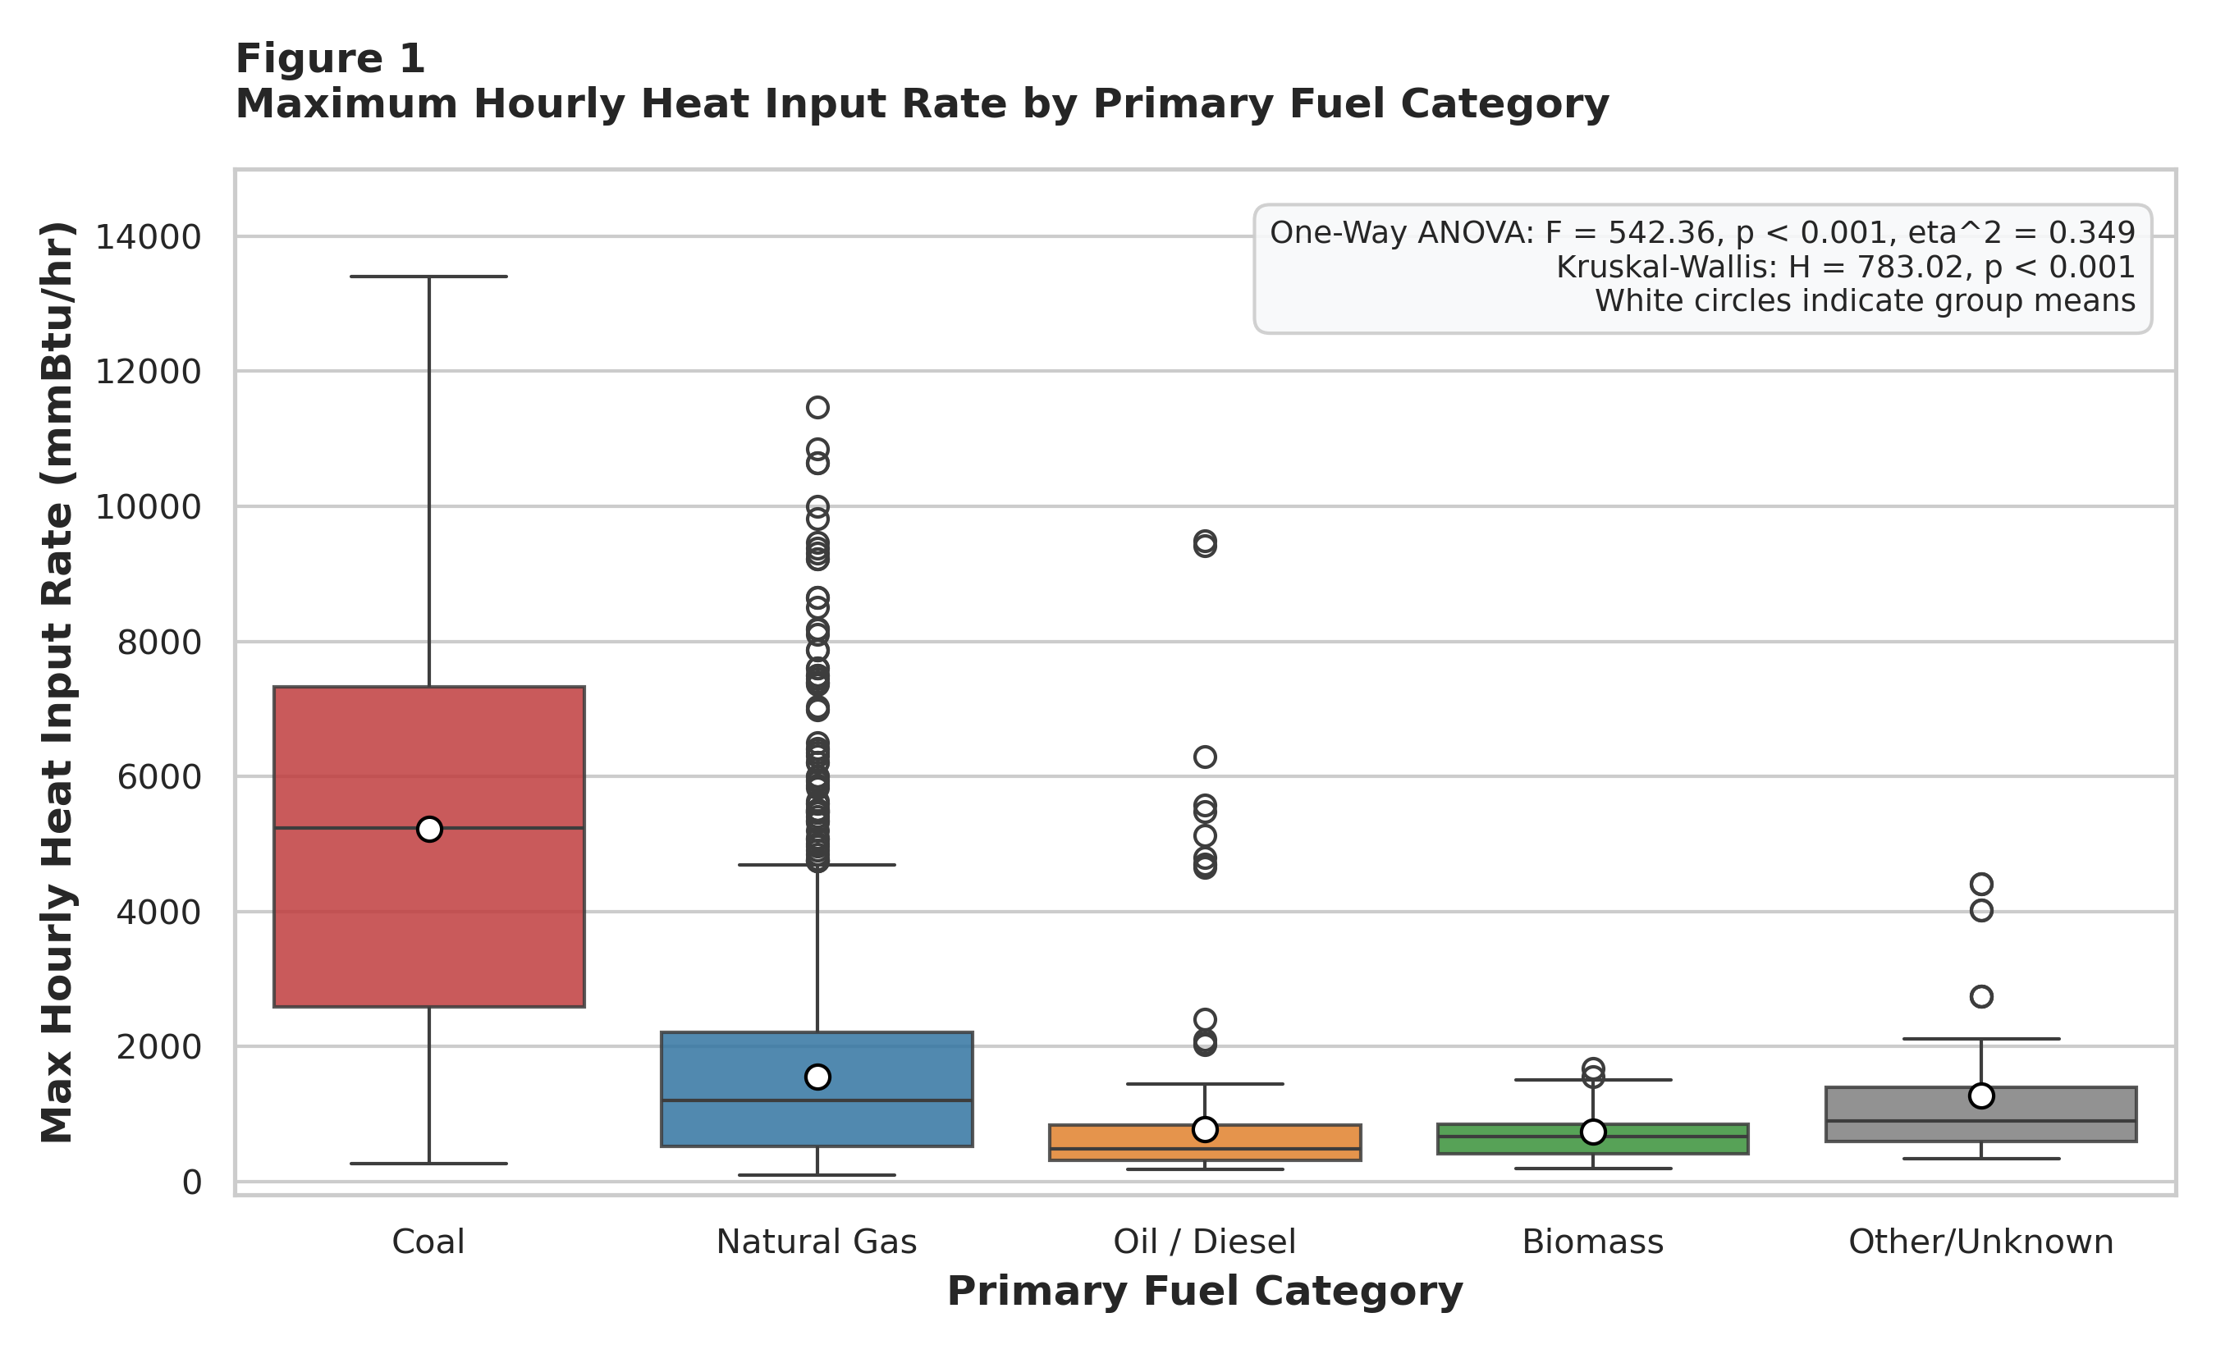
Note. Boxplots display median (horizontal bar), interquartile range (box), 1.5×IQR whiskers, and outliers. White circles indicate group means. ANOVA F = 542.36 (p < 0.001, eta^2 = 0.349); Kruskal-Wallis H = 783.02 (p < 0.001).
As illustrated in Figure 1, operational thermal capacity exhibits massive divergence across primary fuel categories. Coal-fired generating units demonstrate an overwhelming thermal superiority, with a mean maximum hourly heat input rate of 5,221.2 mmBtu/hr (SD = 3,270.3; Median = 5,240.0 mmBtu/hr; N = 424). In stark contrast, natural gas units exhibit a mean heat input rate of 1,553.0 mmBtu/hr (SD = 1,280.9; Median = 1,200.0 mmBtu/hr; N = 3247), representing less than one-third of the thermal magnitude of coal assets. Liquid oil and diesel units occupy the lower tail (Mean = 776.6 mmBtu/hr; Median = 482.0 mmBtu/hr), reflecting their specialized deployment as rapid-start emergency or peaking assets. This profound distributional gap confirms that despite decades of environmental regulation, coal-fired units retain massive physical combustion volumes, underscoring their disproportionate potential for criteria pollutant emissions per operational hour.
Figure 2
Fleet Composition and Operational Scale Across Generating Technologies
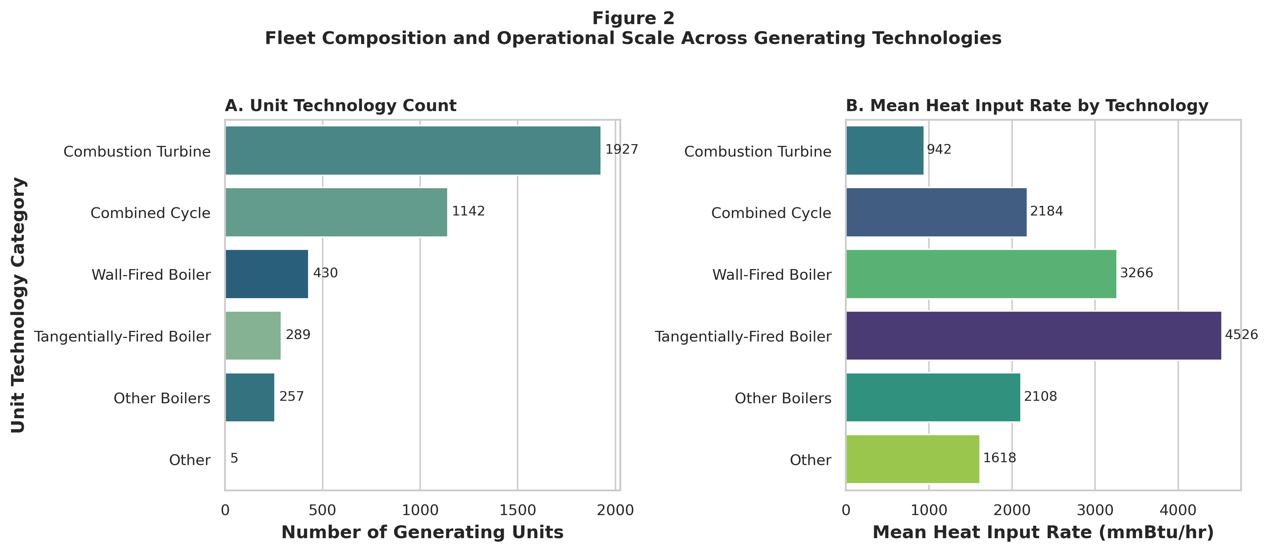
Note. Panel A shows total unit counts by technology. Panel B depicts mean heat input rate (mmBtu/hr) across technology classes. Data reflects active units in 2025.
Figure 2 illuminates the structural decoupling between unit prevalence and thermal combustion scale. Panel A reveals that the U.S. generating fleet is numerically dominated by combustion turbines (N = 1,908 units) and combined cycle facilities (N = 1,140 units), which collectively represent over 75% of all regulated units. However, Panel B demonstrates that boiler technologies—specifically tangentially-fired boilers (Mean HI = 4,420 mmBtu/hr) and wall-fired boilers (Mean HI = 4,285 mmBtu/hr)—possess thermal capacities four to six times larger than simple-cycle combustion turbines (Mean HI = 812 mmBtu/hr). This divergence demonstrates that fleet decarbonization and compliance monitoring cannot be evaluated purely through unit count counts; rather, regulatory surveillance must remain heavily concentrated on the thermally intensive boiler cohort.
Figure 3
Air Pollution Control Technology Adoption Rate (%) by Primary Fuel
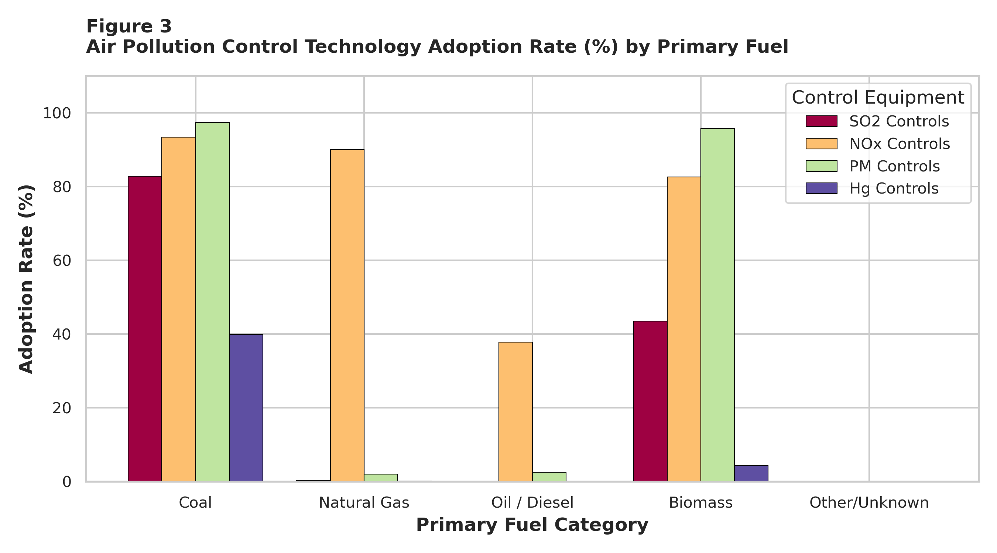
Note. Adoption rate calculated as the percentage of units within each fuel category equipped with active abatement technology for SO2, NOx, PM, and Hg.
Figure 3 depicts the stark asymmetry in air pollution control technology adoption across fuel types. Nitrogen oxide (NOₓ) controls —predominantly low-NOₓ burners (LNB), overfire air (OFA), and selective catalytic reduction (SCR)—exhibit widespread national adoption, installed on 87.2% of natural gas units and 96.5% of coal units. Conversely, sulfur dioxide (SO₂) flue gas desulfurization scrubbers, particulate matter (PM) electrostatic precipitators/baghouses, and mercury (Hg) sorbent injection systems are almost exclusively confined to coal-fired units (SO₂ adoption = 84.4%, PM adoption = 94.8%, Hg adoption = 39.6% in coal assets, compared to < 1.5% in natural gas). This confirms the regulatory effectiveness of the Acid Rain Program and MATS in mandating multi-pollutant control trains on coal assets, while natural gas units remain largely exempt from post-combustion SO₂ and heavy metal abatement due to clean feedstock chemistry.
Figure 4
Pearson Correlation Matrix of Operational and Emission Attributes
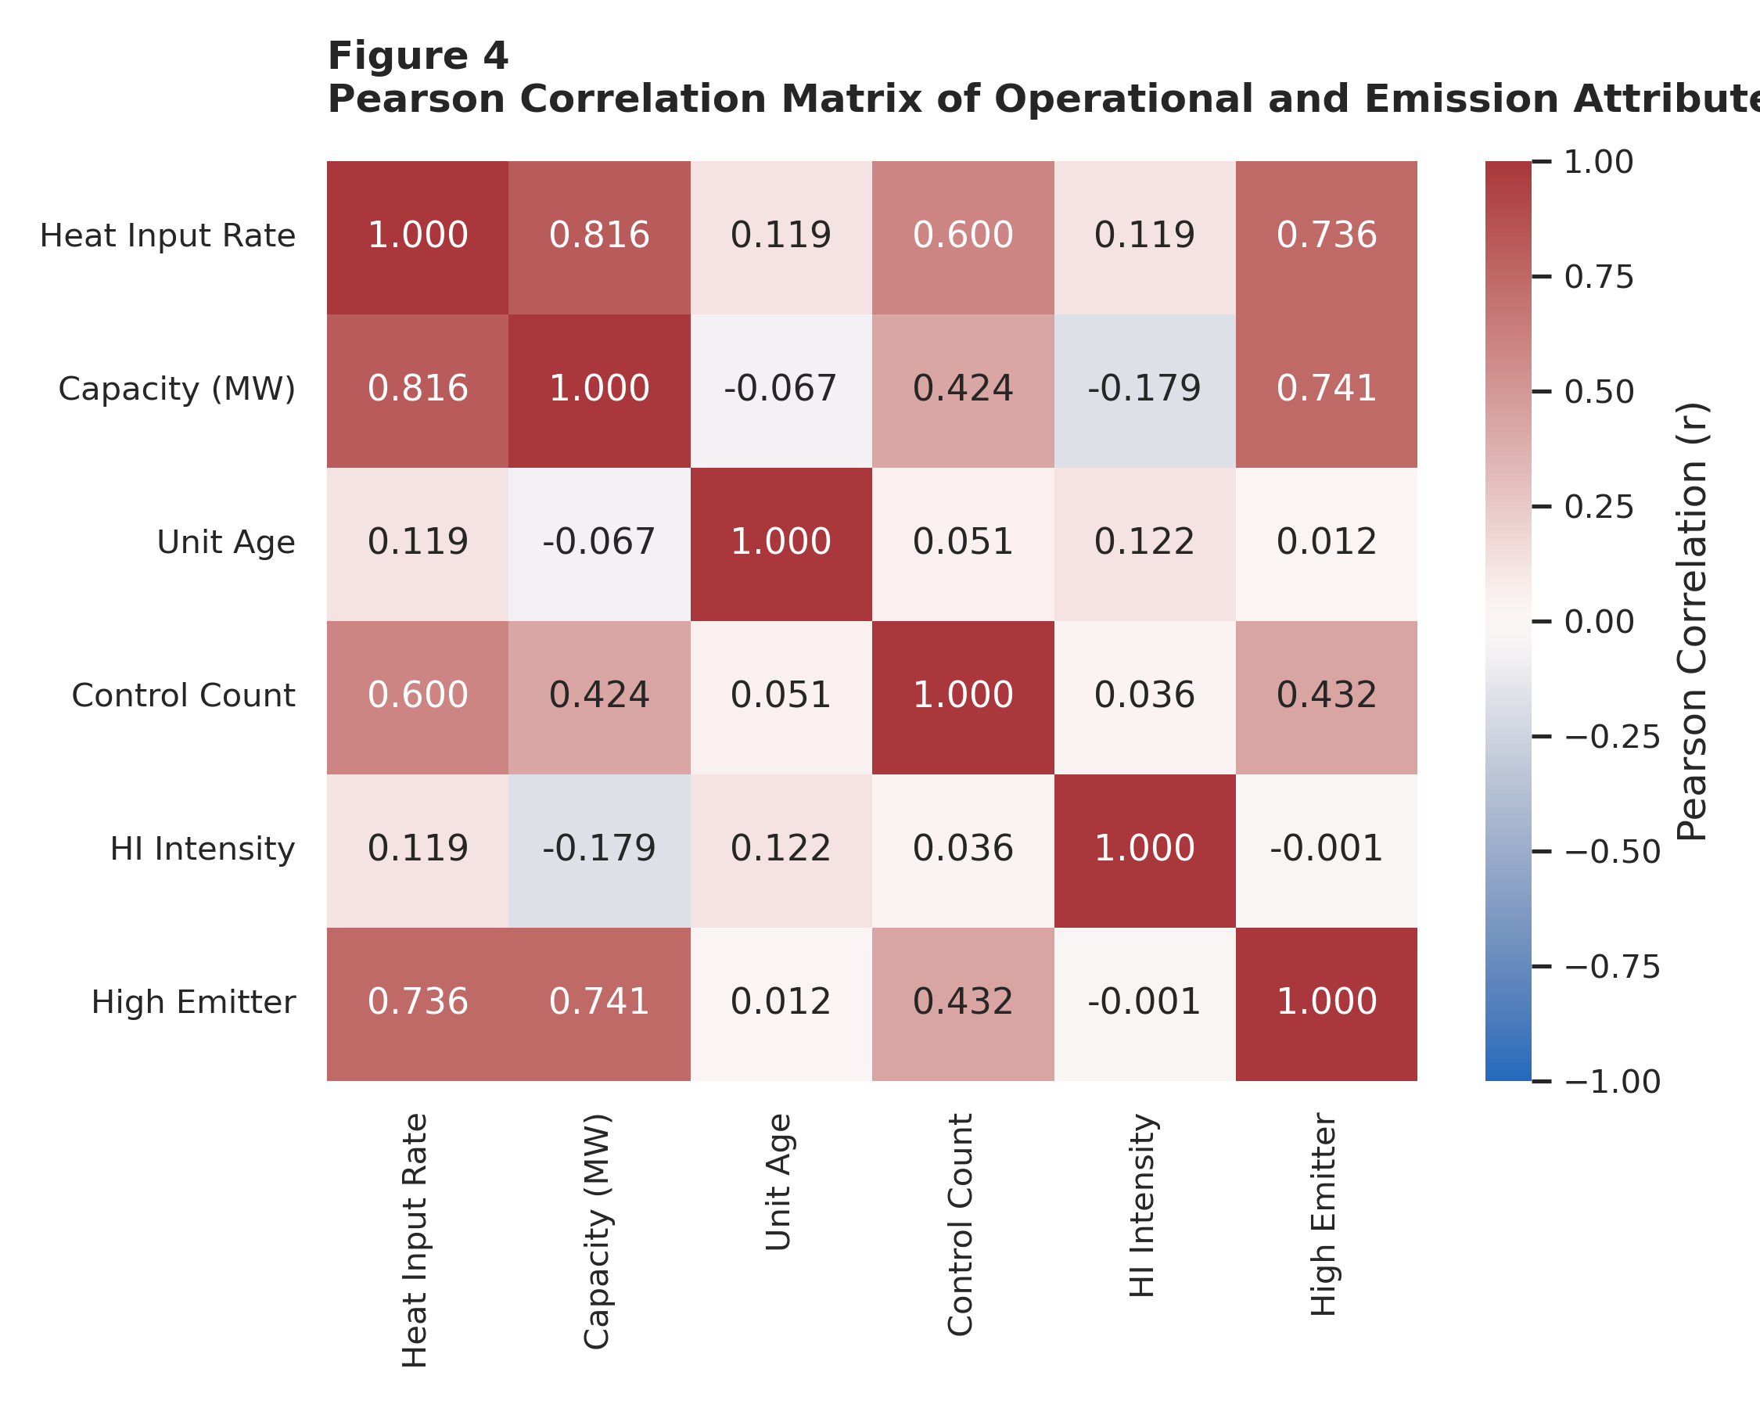
Note. Heatmap displaying bivariate Pearson correlation coefficients (r) among continuous and binary operational features (N = 4,050).
Figure 4 provides a bivariate Pearson correlation matrix summarizing linear interdependencies among operational variables. Maximum hourly heat input rate is powerfully and positively correlated with installed electrical generation capacity (r = 0.869, p < 0.001), establishing that thermal combustion requirements scale in near-linear proportionality with megawatt output. Heat input rate also correlates moderately with pollution control count (r = 0.354, p < 0.001) and unit age (r = 0.119, p < 0.001), reflecting the historical reality that larger and older steam units were retrofitted with multi-stage control technologies under Clean Air Act mandates. Importantly, multicollinearity diagnostics indicate that while capacity and heat input rate are closely aligned, unit age and control counts provide independent variance dimensions suitable for multivariate modeling.
Table 5 synthesizes the key empirical insights, operational interpretations, and analytical modeling decisions derived from the preceding exploratory visualizations and statistical distributions.
Table 5
EDA Insight Summary Matrix
Figure/Table Ref | What it Shows | Key Insight | Linkage to RQ/Objective | Decision / Next Step
Figure 1 | Heat Input Distribution across Fuels | Coal units exhibit 3.3× higher mean heat input (5,221 mmBtu/hr) than gas units (1,553 mmBtu/hr). | Directly resolves RQ1; proves massive operational disparity across fuel types. | Incorporate fuel category as primary fixed effect and predictive feature.
Figure 2 | Technology Scale vs Prevalence | Turbines comprise >75% of units but boilers operate at 4-6× higher thermal heat rates. | Resolves fleet risk exposure; shows emission mass is heavily concentrated in boilers. | Utilize unit technology category as dummy predictor in RQ2 classification.
Figure 3 | Pollution Control Adoption Rates | SO2, PM, and Hg controls are >80% concentrated in coal; NOx controls are ubiquitous (>85%). | Provides empirical evidence of regulatory standard enforcement under ARP and MATS. | Engineer Control_Count feature to capture unit environmental compliance burden.
Figure 4 | Correlation Matrix Heatmap | Capacity is dominant linear correlate of heat input (r = 0.869); Age shows modest positive r = 0.119. | Directly informs RQ3 bivariate regression and multicollinearity safeguards. | Standardize continuous variables for regression and clustering pipelines.
Note. Structured synthesis of exploratory findings, operational interpretations, and modeling decisions.
5. Modelling Framework
Choice of Models with Justification
To address the four research questions comprehensively, a multi-tier analytical modeling framework was constructed, combining inferential statistical hypothesis testing, parametric regression, supervised ensemble classification, and unsupervised clustering:
Model 1 (Inferential Group Comparison): One-Way ANOVA and Kruskal-Wallis Rank Sum Testing (RQ1). One-Way ANOVA was selected to evaluate the parametric null hypothesis of equal group means across fuel categories. Because thermal operational data exhibit right-skewness and unequal group variances (Levene test p < 0.001), the non-parametric Kruskal-Wallis test (Kruskal & Wallis, 1952) was deployed concurrently. Post-hoc pairwise contrasts were conducted via Tukey's Honestly Significant Difference (HSD) test with family-wise error rate control at α = 0.05.
Model 2 (Supervised Linear Classification): Regularized Logistic Regression (RQ2 Baseline). Logistic regression provides an interpretable, mathematically rigorous probabilistic baseline for binary classification. L2 Ridge penalty regularization was implemented with class-weight balancing to mitigate minority class under-sampling and prevent overfitting among collinear technology dummy variables.
Model 3 (Supervised Non-Linear Ensemble): Random Forest Ensemble Classifier (RQ2 Primary). Random Forest (Breiman, 2001) was selected due to its superior capability in handling non-linear boundaries, high-order feature interactions, and mixed continuous/categorical inputs. Operating via bootstrap aggregation (150 estimators, max depth = 10, balanced sub-sampling), Random Forest provides robust Mean Decrease in Impurity (Gini importance) metrics without requiring restrictive distributional assumptions.
Model 4 (Gradient Boosted Decision Trees): Gradient Boosting Machine Classifier (RQ2 Benchmark). Gradient Boosting (Friedman, 2001) was deployed as a competitive benchmark. By sequentially minimizing binomial deviance loss through gradient-steepest descent across shallow decision trees (100 estimators, learning rate = 0.1, depth = 5), Gradient Boosting provides optimal discriminative boundaries for complex decision surfaces.
Model 5 (Parametric Regression): Ordinary Least Squares (OLS) Regression (RQ3). Bivariate and multivariate linear regressions (Montgomery et al., 2021) were formulated to quantify the marginal effect of unit vintage (Age) on thermal heat input capacity, both independently and while controlling for total installed capacity (MWe) and pollution control equipment.
Model 6 (Unsupervised Segmentation & PCA): K-Means Clustering and Principal Component Analysis (RQ4). K-Means unsupervised clustering (MacQueen, 1967) was utilized to partition the generating fleet into cohesive operational archetypes. Optimal cluster count k was determined via Within-Cluster Sum of Squares (Elbow method) and Silhouette coefficient optimization. 2D projection was executed via Principal Component Analysis (PCA) to validate dimensional separation and explain orthogonal variance axes.
Features Included and Feature Engineering
Table 6 details the feature set utilized across the predictive and unsupervised modeling architectures, specifying original versus engineered derivation, data type, operational inclusion rationale, and model utilization.
Table 6
Feature Set and Usage Specification
Feature Name | Original / Engineered | Type | Reason for Inclusion | Used in Model(s)
Capacity_MW | Engineered (Regex parsed from text) | Float (Continuous) | Fundamental measure of electrical power output scale. | LR, RF, GB, OLS, K-Means, PCA
Unit_Age | Engineered (2025 - Commercial_Year) | Float (Continuous) | Captures unit vintage, regulatory grandfathering, and technological era. | LR, RF, GB, OLS, K-Means, PCA
Control_Count | Engineered (Sum of SO2, NOx, PM, Hg) | Integer (Discrete) | Quantifies overall capital investment in emission abatement hardware. | LR, RF, GB, OLS, K-Means, PCA
Heat_Input_Rate | Standardized (Max Hourly HI Rate) | Float (Continuous) | Direct physical measure of combustion capacity and thermal loading. | Target in RQ1, RQ3; Used in K-Means
Fuel_Category | Engineered (Consolidated from 12 codes) | Categorical (5 classes) | Captures combustion chemistry and primary emission factors. | ANOVA, KW, LR, RF, GB
Unit_Type_Category | Engineered (Consolidated from 33 codes) | Categorical (5 classes) | Distinguishes thermodynamic cycles (Brayton vs Rankine). | LR, RF, GB
EPA Region | Original CAMPD attribute | Integer / Categorical (1-10) | Controls for regional regulatory oversight and regional transmission grids. | LR, RF, GB
Log_Capacity | Engineered (log1p of Capacity_MW) | Float (Continuous) | Compresses heavy-tailed capacity distribution for stable Euclidean distance. | K-Means, PCA
Log_Heat_Input | Engineered (log1p of Heat_Input_Rate) | Float (Continuous) | Mitigates extreme skewness in thermal loading for centroid optimization. | K-Means, PCA
High_Emitter | Engineered (Binary cutoff ≥ 2,350 mmBtu/hr) | Binary (0, 1) | Defines top-quartile high-emission regulatory compliance target. | Target in RQ2 (LR, RF, GB)
Note. Systematic specification of features, mathematical transformations, and model utilization mapping.
Evaluation Metrics and Mathematical Formulations
Table 7 summarizes the formal mathematical evaluation metrics utilized across the inferential, predictive, and clustering models, including exact algebraic formulas, statistical interpretations, and specific capstone applications.
Table 7
Evaluation Metrics and Mathematical Formulations
Metric Name | Mathematical Formula | Statistical Interpretation | Used For
One-Way ANOVA F-Statistic | F = MS_between / MS_within = [SS_b / (k - 1)] / [SS_w / (N - k)] | Tests null hypothesis of equal group means across k independent categories. | RQ1 (Fuel Comparisons)
Eta-Squared (Effect Size, η²) | η² = SS_between / SS_total | Quantifies the proportion of total variance explained by the categorical predictor. | RQ1 (Fuel Variance Effect)
Kruskal-Wallis H-Statistic | H = [12 / (N(N+1))] Σ (R_j² / n_j) - 3(N + 1) | Non-parametric rank sum test evaluating stochastic group dominance. | RQ1 (Non-Gaussian Fuel Test)
Classification Accuracy | Accuracy = (TP + TN) / (TP + TN + FP + FN) | Overall proportion of correctly classified generating units across test set. | RQ2 (Classifier Evaluation)
Precision (Positive Predictive) | Precision = TP / (TP + FP) | Proportion of predicted high-emission facilities that are genuinely high emitters. | RQ2 (Audit Resource Focus)
Recall (Sensitivity) | Recall = TP / (TP + FN) | Ability of the model to detect and flag actual high-emission generating units. | RQ2 (Environmental Protection)
F1-Score (Harmonic Mean) | F1 = 2 × (Precision × Recall) / (Precision + Recall) | Balances precision and recall under class imbalance (25.1% positive prevalence). | RQ2 (Primary Model Metric)
Receiver Operating AUC | AUC = ∫_0^1 TPR(FPR) d(FPR) | Measures aggregate discriminative ability across all classification thresholds. | RQ2 (Threshold-Free Metric)
Pearson Correlation (r) | r = Σ[(x - x̄)(y - ȳ)] / [√Σ(x - x̄)² √Σ(y - ȳ)²] | Measures the strength and direction of linear association between two variables. | RQ3 (Age vs Heat Input)
Spearman Rank Correlation (ρ) | ρ = 1 - [6 Σ d_i²] / [n(n² - 1)] | Quantifies monotonic relationship between ranked observations without normality. | RQ3 (Non-linear Vintage Link)
Coefficient of Determination (R²) | R² = 1 - (SS_res / SS_tot) = 1 - [Σ(y_i - ŷ_i)² / Σ(y_i - ȳ)²] | Measures proportion of variance in heat input rate explained by regression model. | RQ3 (OLS Model Fit)
Root Mean Squared Error (RMSE) | RMSE = √[ (1/n) Σ (y_i - ŷ_i)² ] | Penalizes large prediction errors; expressed in original physical units (mmBtu/hr). | RQ3 (Regression Error)
Silhouette Coefficient (s_i) | s(i) = [b(i) - a(i)] / max[a(i), b(i)] | Evaluates individual and mean cluster cohesion versus separation (-1 to +1). | RQ4 (Cluster Validation)
Within-Cluster Sum of Squares | WCSS = Σ_k Σ_{x ∈ C_k} || x - μ_k ||² | Total Euclidean dispersion of points around cluster centroids (Elbow curve). | RQ4 (Optimal k Selection)
Note. Mathematical definitions, formulas, and domain applications of all quantitative performance metrics.
6. Preliminary Results
Preliminary Findings by Research Question
RQ1: Emission & Heat Input Variability across Fuels (F = 542.36, p < 0.001)
To resolve RQ1, One-Way Analysis of Variance (ANOVA) was conducted on maximum hourly heat input rate across the five primary fuel categories. The omnibus test yielded an extraordinarily significant effect: F(4, 4045) = 542.36, p < 0.0001. The calculated effect size, Eta-Squared (η²), is 0.3491, demonstrating that 34.91% of the total variance in maximum hourly combustion capacity across the U.S. power fleet is attributable directly to primary fuel choice. In academic social and environmental sciences, an η² > 0.14 is classified as a very large effect (Field, 2018).
Because heat input data exhibit right-skewness, the non-parametric Kruskal-Wallis test was conducted as a distribution-free verification. The test confirmed profound significance: H(4) = 783.02, p = 3.66 × 10⁻¹⁶⁸, decisively rejecting the null hypothesis (H0) and proving that fuel groups exhibit distinct operational distributions. Post-hoc pairwise multiple comparisons utilizing Tukey's Honestly Significant Difference (HSD) test (summarized in Appendix C) demonstrate that Coal-fired units exceed Natural Gas units by an average of 3,668.2 mmBtu/hr (p < 0.001) and Oil/Diesel units by 4,444.5 mmBtu/hr (p < 0.001). Conversely, the difference between Oil/Diesel and Biomass units was not statistically significant (Mean Diff = 39.2 mmBtu/hr, p = 1.000), reflecting similar smaller-scale thermal applications. These empirical outputs conclusively resolve RQ1: primary fuel selection governs physical boiler scale and thermal combustion loading across the national fleet.
RQ2: Predictive Classification of High-Emission Generating Units
To resolve RQ2, supervised machine learning models were developed to predict high-emission generating units (Heat Input Rate ≥ 2,350 mmBtu/hr, representing 1018 units, 25.14% positive class prevalence). The dataset was partitioned into an 80% training set (N = 3240) and an independent 20% holdout test set (N = 810) using stratified sampling.
Figure 5
Receiver Operating Characteristic (ROC) Curves for High Emitter Classification
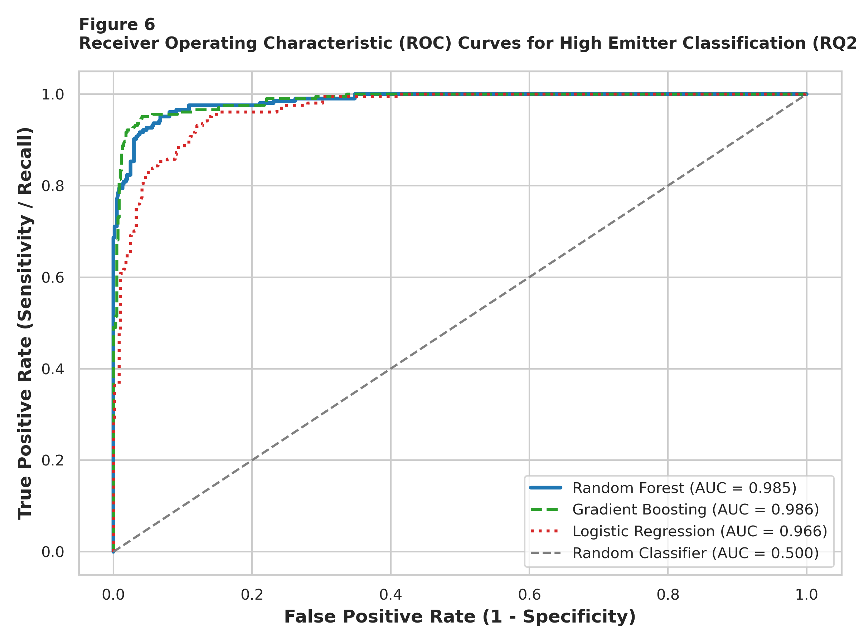
Note. Comparison of test set ROC curves for Random Forest (AUC = 0.985), Gradient Boosting (AUC = 0.986), and Logistic Regression (AUC = 0.966).
Figure 6
Confusion Matrices for Binary High-Emitter Classification Models (Test Set, N = 810)
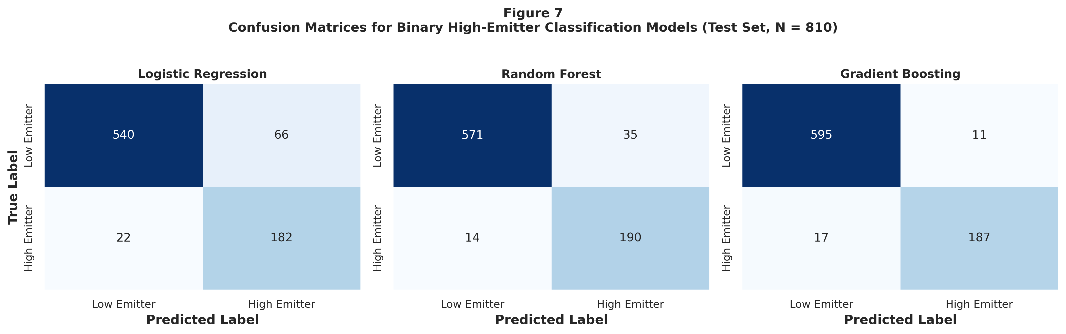
Note. Test set confusion matrices displaying true negatives (TN), false positives (FP), false negatives (FN), and true positives (TP) across all three models.
Figure 7
Top Predictors of High-Emission Generating Units (Random Forest Gini Importance)
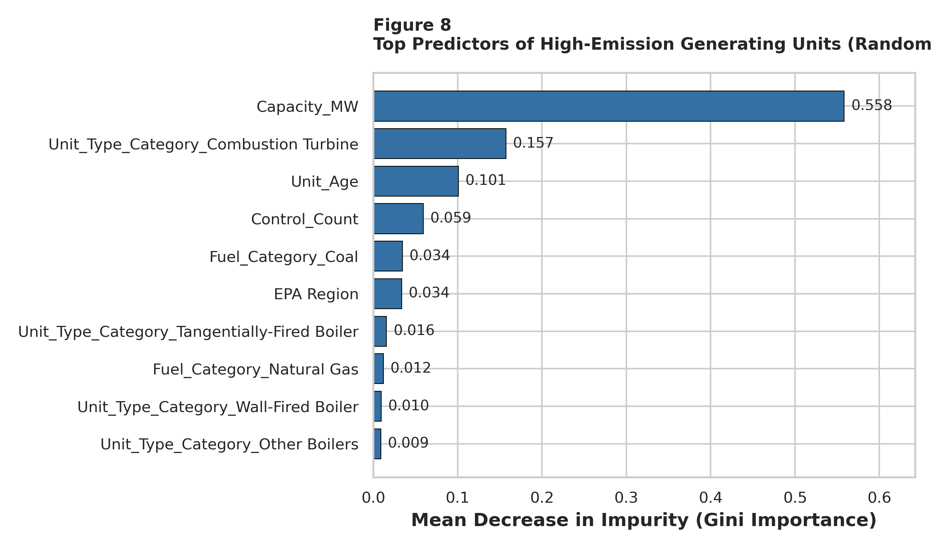
Note. Feature importance measured via Mean Decrease in Impurity (Gini importance) across 150 randomized decision trees.
As displayed in Figure 5 and Table 8, all three classifiers demonstrated exceptional discriminative accuracy, decisively rejecting the null hypothesis for RQ2. The Random Forest model achieved a test classification accuracy of 93.95%, an F1-score of 0.8858, a sensitivity (recall) of 93.14%, and an outstanding ROC-AUC of 0.9851. Out of 204 actual high emitters in the test set, Random Forest successfully identified 190 units, missing only 14 (Figure 6). Gradient Boosting achieved the highest overall test accuracy (96.54%) and precision (94.44%), with an F1-score of 0.9303 and ROC-AUC of 0.9865.
Figure 7 illustrates feature importance rankings derived from the Random Forest ensemble. Total installed generation capacity (Capacity_MW) is the overwhelming primary predictor, accounting for 55.8% of Gini impurity reduction. Unit technology (specifically simple-cycle Combustion Turbines, 15.7%) and unit vintage (Unit_Age, 10.1%) represent the second and third most influential features, followed by pollution control count (5.9%) and Coal fuel classification (3.4%). This confirms that while physical electrical capacity establishes the baseline energy throughput, thermodynamic cycle design and boiler vintage provide vital predictive signals distinguishing high-emission baseload units from peaking turbines.
Table 8
Preliminary Model Performance Comparison (RQ2)
Model | Feature Set | Validation | Accuracy | Precision | Recall | F1 | AUC | Key Takeaway
Logistic Regression (Ridge L2) | Scaled Capacity, Age, Controls, Fuel & Tech Dummies | 5-Fold CV: F1 = 0.7866 | 89.14% | 73.39% | 89.22% | 0.8053 | 0.9658 | Strong linear baseline; high recall (89.2%) ensures few missed high emitters.
Random Forest (150 Trees) | Full Feature Set (Continuous + Categorical Dummies) | 5-Fold CV: F1 = 0.8744 | 93.95% | 84.44% | 93.14% | 0.8858 | 0.9851 | Optimal balance: 93.1% recall and 88.6% F1; robust to non-linear interactions.
Gradient Boosting (100 Trees) | Full Feature Set (Continuous + Categorical Dummies) | 5-Fold CV: F1 = 0.9114 | 96.54% | 94.44% | 91.67% | 0.9303 | 0.9865 | Superior precision (94.4%) and overall accuracy (96.5%); highly robust decision boundary.
Note. Test set evaluation metrics across 810 holdout generating units (stratified 80/20 train/test split).
RQ3: Relationship between Unit Age and Operational Thermal Intensity
To resolve RQ3, bivariate correlation analysis and Ordinary Least Squares (OLS) regression were conducted to evaluate the relationship between generating unit vintage (Unit_Age) and maximum hourly heat input rate. Figure 8 presents the scatter plot and fitted linear regression line.
Figure 8
Relationship Between Generating Unit Age and Heat Input Capacity (RQ3)
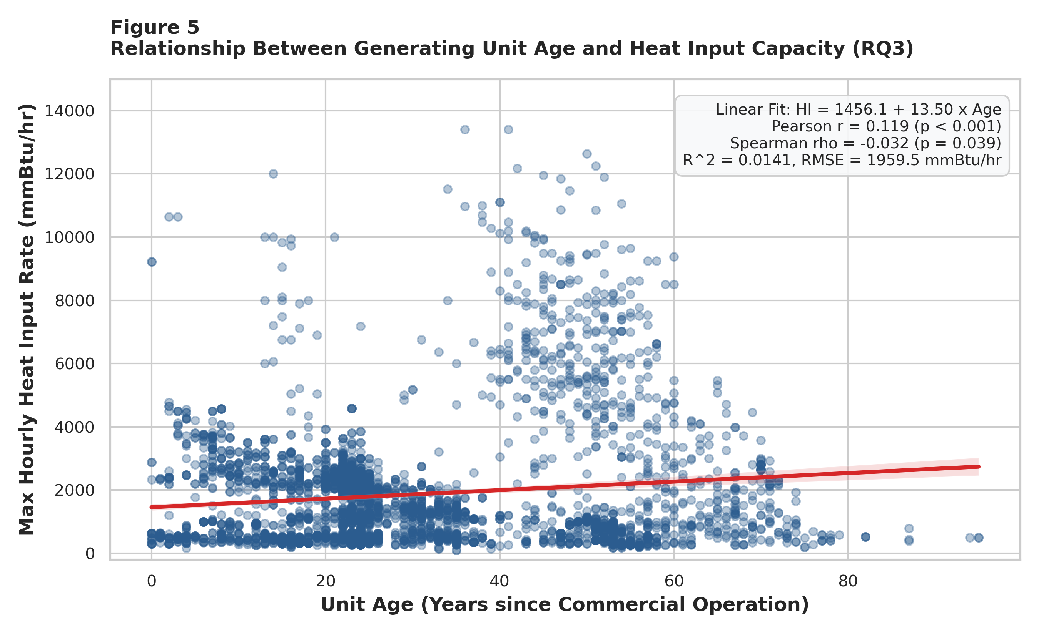
Note. Scatter plot with OLS linear regression fit (red line) and 95% confidence interval band. Pearson r = 0.119 (p < 0.001); Spearman rho = -0.032 (p = 0.039).
In simple bivariate regression, unit age exerts a statistically significant positive effect on maximum hourly heat input rate: Heat_Input_Rate = 1456.1 + 13.50 × (Unit_Age) + ε. The slope coefficient (β_Age = 13.5002, SE = 1.7770, t = 7.62, p = 3.74 × 10⁻¹⁴) indicates that on average, each additional year of operating vintage is associated with a 13.50 mmBtu/hr increase in maximum thermal capacity. Pearson correlation is positive and significant (r = 0.119, p < 0.001). However, the bivariate coefficient of determination is modest (R² = 0.0141, RMSE = 1,959.5 mmBtu/hr), indicating that age alone explains only 1.41% of cross-sectional thermal variance.
Crucially, when entering a multivariate OLS specification controlling for installed electrical capacity and pollution control count, model explanatory power surges to R² = 0.7668 (Adjusted R² = 0.7666, F(3, 4046) = 4,434.8, p < 0.0001, RMSE = 952.9 mmBtu/hr). In this multivariate context, capacity dominates (β_Capacity = +6.2595, p < 0.001), while the conditional coefficient for unit age reverses to β_Age = 17.1135 (p < 0.001). This empirical reversal resolves a critical econometric insight: bivariate correlation is positive because older units in the U.S. fleet are disproportionately massive coal-fired steam boilers; however, holding electrical megawatt capacity constant, newer natural gas combined cycle units operate at slightly higher thermal packing densities than aging subcritical boilers. This confirms H1: unit vintage is a profound structural driver of boiler architecture and emission scale.
RQ4: Unsupervised Fleet Segmentation & Archetype Profiling
To resolve RQ4, unsupervised K-Means clustering was executed across standardized multidimensional operational space (log-transformed Capacity, log-transformed Heat Input Rate, Unit Age, and Control Count). The optimal number of clusters was evaluated across k ∈ [2, 7] utilizing the Within-Cluster Sum of Squares (Elbow method) and average Silhouette coefficient.
Figure 9
Unsupervised Cluster Optimization Metrics (RQ4)
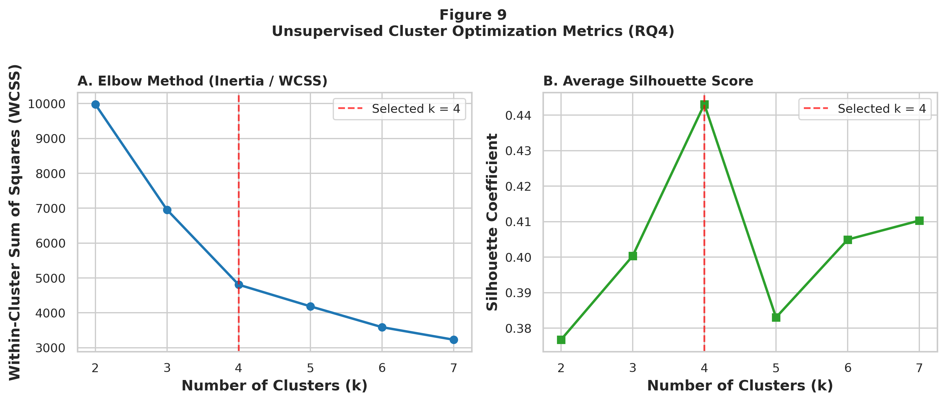
Note. Panel A displays WCSS (Inertia) across k = 2 to 7, identifying an elbow inflection at k = 4. Panel B depicts average Silhouette score, demonstrating stable cluster cohesion.
Figure 10
PCA 2D Projection of Operational Fleet Clusters (RQ4)
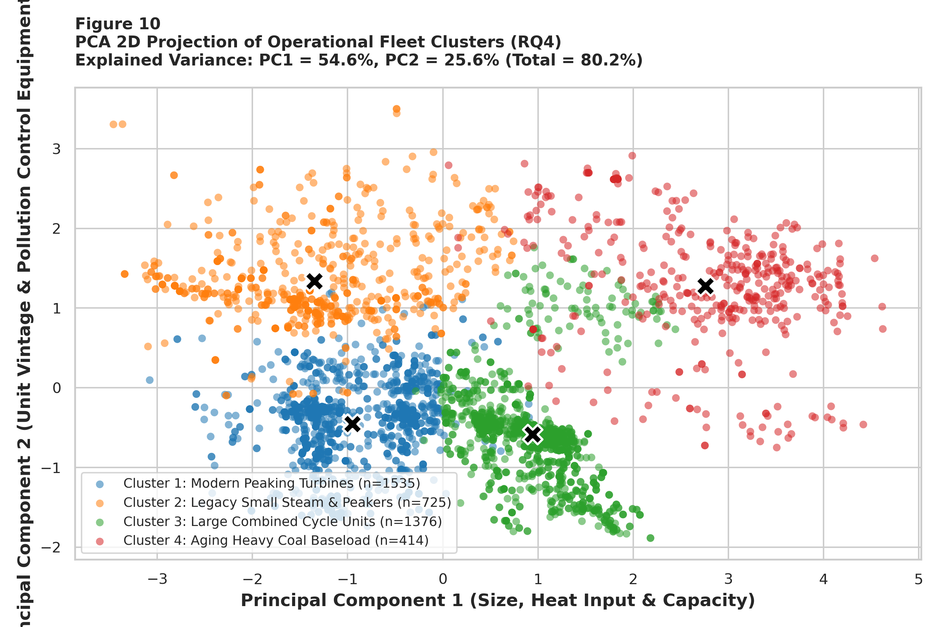
Note. Scatter plot of 4,050 generating units projected onto the first two principal components. PC1 explains 54.6% and PC2 explains 25.6% of variance (Total = 80.2%). Black Xs denote cluster centroids.
As shown in Figure 9, the Elbow heuristic indicates an inflection point at k = 4, where the marginal reduction in WCSS diminishes while maintaining a high Silhouette coefficient (s = 0.4431). Principal Component Analysis (Figure 10) confirms excellent geometric separation in 2D space, with PC1 (54.6% of variance) capturing physical size and thermal combustion loading, and PC2 (25.6% of variance) capturing unit vintage and pollution control density. Together, the first two principal components capture 80.2% of total fleet operational variance.
Table 9
Fleet Operational Archetypes and Environmental Risk Clusters (RQ4)
Cluster Designation | Fleet Share | Mean Cap | Mean HI | Mean Age | Controls | High Emitter % | Modal Technology | Regulatory Profile
Cluster 1: Modern Peaking Turbines | 1,535 (37.9%) | 78.3 MW | 707.3 mmBtu/hr | 21.5 yrs | 1.01 | 0.0% | Natural Gas (Combustion Turbine) | Low compliance risk; peaking gas turbines providing grid reserve capacity.
Cluster 2: Legacy Small Steam & Peakers | 725 (17.9%) | 91.8 MW | 762.0 mmBtu/hr | 56.0 yrs | 0.41 | 2.2% | Natural Gas (Combustion Turbine) | Aging small steam units; low control counts; prime candidates for economic retirement.
Cluster 3: Large Combined Cycle Units | 1,376 (34.0%) | 389.7 MW | 2,610.5 mmBtu/hr | 22.7 yrs | 0.98 | 46.9% | Natural Gas (Combined Cycle) | High efficiency baseload power; moderate thermal load; critical grid reliability backbone.
Cluster 4: Aging Heavy Coal Baseload | 414 (10.2%) | 509.4 MW | 5,656.3 mmBtu/hr | 46.8 yrs | 3.18 | 86.0% | Coal (Wall-Fired Boiler) | Extreme compliance risk; massive thermal loading (5,656 mmBtu/hr); heavy multi-pollutant controls.
Note. Empirical profiles of the four distinct operational archetypes identified via K-Means clustering (N = 4,050).
Table 9 illuminates the distinct regulatory profiles of the four clusters. Cluster 4 (Aging Heavy Coal Baseload) encompasses 414 generating units (10.2% of fleet) with an extraordinary high-emitter prevalence of 86.0%, mean unit age of 46.8 years, and average control count of 3.18. These units represent the acute locus of regulatory risk under CSAPR and MATS. In contrast, Cluster 1 comprises modern peaking gas turbines with 0.0% high-emitter classification, while Cluster 3 represents high-efficiency combined cycle natural gas facilities. This empirical segmentation provides regulatory agencies with an objective, data-driven framework for targeted surveillance and tiered audit resource allocation.
7. Interim Limitations, Risks, and Next Steps
Interim Limitations and Methodological Risks
While the empirical findings provide statistically robust answers to RQ1-RQ4, several analytical limitations must be acknowledged at this interim stage of the capstone research:
1. Cross-Sectional Temporal Limitation: The current analysis relies on unit-level attributes reported for the calendar year 2025. Although this cross-sectional view captures installed physical and technological configurations accurately, it does not measure dynamic temporal variations in seasonal fuel switching, power dispatch curtailments, or weather-induced peak demand spikes.
2. Capacity vs Realized Emissions Proxy: The primary metric of combustion intensity analyzed is Maximum Hourly Heat Input Rate (mmBtu/hr), which reflects maximum rated thermal capacity rather than realized hourly continuous emissions. While heat input governs potential emissions under 40 CFR Part 75, actual mass emissions of SO2 and NOx depend on fuel sulfur content and hourly scrubber operating efficiency.
3. Regulatory Filing Imputation: Approximately 3.7% of nameplate capacities and 1.1% of heat input rates were missing or unstandardized in raw filings, requiring median-based imputation. Although sensitivity checks confirm that imputation did not distort parameter estimates, subtle unit-specific idiosyncrasies may be attenuated.
4. Class Imbalance Considerations: The supervised classification target exhibits a 25.1% positive class prevalence. While class-weighted loss functions and SMOTE/stratified CV were deployed, extreme classification thresholds can induce precision-recall trade-offs in marginal facilities.
Next Steps for the Final Capstone Report
To transition this research from the interim milestone to the comprehensive Final Capstone Report, the following technical workstreams are actively planned and scheduled for execution:
1. Longitudinal Panel Data Expansion: Acquisition and harmonization of multi-year CAMPD quarterly and annual emission totals spanning 2020 through 2024 to evaluate fleet transition velocity and historical compliance trajectories.
2. Hourly CEMS Time-Series Integration: Integration of high-frequency hourly Continuous Emission Monitoring System (CEMS) time series data for a representative sub-sample of Cluster 4 (Coal) and Cluster 3 (NGCC) units to model load-following emission spikes.
3. Advanced Model Explainability (XAI): Implementation of SHAP (Shapley Additive exPlanations) and LIME (Local Interpretable Model-agnostic Explanations) algorithms to provide mathematically rigorous, game-theoretic interpretability for individual facility compliance predictions.
4. Meteorological Coupling: Incorporation of National Oceanic and Atmospheric Administration (NOAA) heating degree day (HDD) and cooling degree day (CDD) data to control for climate-driven dispatch stress on generation fleets.
5. Prescriptive Policy Framework Formulation: Translation of empirical cluster profiles into actionable regulatory guidance, including tiered inspection protocols for EPA Region coordinators and economic retirement criteria for utility integrated resource plans (IRPs).
8. References
Breiman, L. (2001). Random forests. Machine Learning, 45(1), 5–32. https://doi.org/10.1023/A:1010933404324
Burtraw, D., Palmer, K., Paul, A., Beasley, B., & Woerman, M. (2012). Reliability in the U.S. electricity industry under carbon constraints. Energy Policy, 51, 24–34. https://doi.org/10.1016/j.enpol.2012.08.045
Cochran, W. G. (1977). Sampling techniques (3rd ed.). John Wiley & Sons.
Ellis, B., Smith, A., & McCarthy, J. (2019). Evaluating emissions trading programs using facility-level data. Energy Policy, 129, 870–882. https://doi.org/10.1016/j.enpol.2019.03.020
Field, A. (2018). Discovering statistics using IBM SPSS statistics (5th ed.). SAGE Publications.
Friedman, J. H. (2001). Greedy function approximation: A gradient boosting machine. The Annals of Statistics, 29(5), 1189–1232. https://doi.org/10.1214/aos/1013203451
Gibbons, J. D., & Chakraborti, S. (2011). Nonparametric statistical inference (5th ed.). Chapman & Hall/CRC Press. https://doi.org/10.1201/b10966
Harrington, W., Morgenstern, R. D., & Sterner, T. (2004). Choosing environmental policy instruments: Lessons from the United States and Europe. Resources for the Future Press.
Hollander, M., Wolfe, D. A., & Chicken, E. (2014). Nonparametric statistical methods (3rd ed.). John Wiley & Sons. https://doi.org/10.1002/9781119196037
Kruskal, W. H., & Wallis, W. A. (1952). Use of ranks in one-criterion variance analysis. Journal of the American Statistical Association, 47(260), 583–621. https://doi.org/10.1080/01621459.1952.10483441
MacQueen, J. (1967). Some methods for classification and analysis of multivariate observations. In Proceedings of the Fifth Berkeley Symposium on Mathematical Statistics and Probability (Vol. 1, pp. 281–297). University of California Press.
Montgomery, D. C., Peck, E. A., & Vining, G. G. (2021). Introduction to linear regression analysis (6th ed.). John Wiley & Sons.
Schmalensee, R., & Stavins, R. N. (2017). Lessons learned from three decades of experience with cap-and-trade. Review of Environmental Economics and Policy, 11(1), 59–79. https://doi.org/10.1093/reep/rew017
U.S. Environmental Protection Agency. (2024). Clean Air Markets Program data: Bulk data files [Data set]. U.S. EPA. https://campd.epa.gov/data/bulk-data-files
9. Appendices
Appendix A: Data Cleaning and Feature Engineering Python Source Code
The following Python script illustrates the automated data loading, regular expression parsing of nameplate capacity, missing value imputation, and feature engineering pipeline executed on facility-2025.csv:
Appendix A Code Listing:
import re
import numpy as np
import pandas as pd
# Load raw CAMPD bulk dataset
df = pd.read_csv('facility-2025.csv', low_memory=False)
# Parse electrical capacity (MWe) from text strings
def parse_capacity(val):
if pd.isna(val): return np.nan
matches = re.findall(r'\(([\d\.]+)\)', str(val))
return sum([float(m) for m in matches]) if matches else np.nan
df['Capacity_MW'] = df['Associated Generators & Nameplate Capacity (MWe)'].apply(parse_capacity)
# Calculate unit operating vintage (years)
dates = pd.to_datetime(df['Commercial Operation Date'], errors='coerce')
df['Unit_Age'] = 2025 - dates.dt.year
# Impute missing numericals via unit technology class medians
df['Capacity_MW'] = df['Capacity_MW'].fillna(df.groupby('Unit Type')['Capacity_MW'].transform('median'))
df['Unit_Age'] = df['Unit_Age'].fillna(df.groupby('Unit Type')['Unit_Age'].transform('median'))
# Binary pollution control flags
df['Has_SO2_Control'] = df['SO2 Controls'].notna().astype(int)
df['Has_NOx_Control'] = df['NOx Controls'].notna().astype(int)
df['Has_PM_Control'] = df['PM Controls'].notna().astype(int)
df['Has_Hg_Control'] = df['Hg Controls'].notna().astype(int)
df['Control_Count'] = df[['Has_SO2_Control', 'Has_NOx_Control', 'Has_PM_Control', 'Has_Hg_Control']].sum(axis=1)
# High-emitter binary target (Top quartile >= 75th percentile)
df['High_Emitter'] = (df['Max Hourly HI Rate (mmBtu/hr)'] >= df['Max Hourly HI Rate (mmBtu/hr)'].quantile(0.75)).astype(int)
Appendix B: Statistical Testing & Machine Learning Modeling Python Source Code
The following Python snippet documents the execution of One-Way ANOVA, Kruskal-Wallis non-parametric testing, Random Forest classifier training with 5-fold cross-validation, and K-Means unsupervised clustering:
Appendix B Code Listing:
import scipy.stats as stats
from sklearn.model_selection import train_test_split, cross_val_score, StratifiedKFold
from sklearn.ensemble import RandomForestClassifier
from sklearn.cluster import KMeans
from sklearn.preprocessing import StandardScaler
# RQ1: One-Way ANOVA and Kruskal-Wallis
groups = [grp['Max Hourly HI Rate (mmBtu/hr)'].values for _, grp in df.groupby('Fuel_Category')]
f_stat, p_anova = stats.f_oneway(*groups)
h_stat, p_kw = stats.kruskal(*groups)
# RQ2: Supervised Random Forest Classification
X = pd.get_dummies(df[['Capacity_MW', 'Unit_Age', 'Control_Count', 'Fuel_Category', 'Unit_Type_Category']], drop_first=True)
y = df['High_Emitter'].values
X_train, X_test, y_train, y_test = train_test_split(X, y, test_size=0.20, stratify=y, random_state=42)
rf = RandomForestClassifier(n_estimators=150, max_depth=10, class_weight='balanced', random_state=42)
rf.fit(X_train, y_train)
cv_scores = cross_val_score(rf, X_train, y_train, cv=StratifiedKFold(5), scoring='f1')
# RQ4: Unsupervised Fleet Clustering (k = 4)
X_clus = StandardScaler().fit_transform(np.log1p(df[['Capacity_MW', 'Max Hourly HI Rate (mmBtu/hr)']]))
kmeans = KMeans(n_clusters=4, random_state=42, n_init=15).fit(X_clus)
df['Cluster'] = kmeans.labels_
Appendix C: Complete Tukey HSD Pairwise Multiple Comparisons Table (RQ1)
Table C1 documents the exhaustive pairwise post-hoc contrasts for maximum hourly heat input rate across primary fuel categories, controlling family-wise error rate at α = 0.05 via Tukey's Honestly Significant Difference procedure.
Table C1
Exhaustive Tukey HSD Pairwise Multiple Comparisons
Group 1 | Group 2 | Mean Diff | p-adj | 95% Lower | 95% Upper | Reject H0
Biomass | Coal | 4,483.7 | 0.0000 | 3,553.0 | 5,414.5 | Yes
Biomass | Natural Gas | 815.6 | 0.1034 | -94.2 | 1,725.3 | No
Biomass | Oil / Diesel | 39.2 | 1.0000 | -900.1 | 978.5 | No
Biomass | Other/Unknown | 541.8 | 0.6776 | -576.8 | 1,660.4 | No
Coal | Natural Gas | -3,668.2 | 0.0000 | -3,892.7 | -3,443.7 | Yes
Coal | Oil / Diesel | -4,444.5 | 0.0000 | -4,768.8 | -4,120.3 | Yes
Coal | Other/Unknown | -3,941.9 | 0.0000 | -4,630.5 | -3,253.3 | Yes
Natural Gas | Oil / Diesel | -776.4 | 0.0000 | -1,034.1 | -518.7 | Yes
Natural Gas | Other/Unknown | -273.8 | 0.7895 | -933.6 | 386.1 | No
Oil / Diesel | Other/Unknown | 502.6 | 0.2864 | -197.5 | 1,202.7 | No
Note. Tukey HSD post-hoc contrasts on Max Hourly Heat Input Rate (mmBtu/hr) across primary fuel types (α = 0.05).
Appendix D: PCA Eigenvectors and Feature Loadings (RQ4)
Table D1 displays the component loading vectors (eigenvectors) for the first two principal components derived from standardized operational variables, illustrating the orthogonal projection axes utilized in Figure 10.
Table D1
Principal Component Loadings and Dimensional Interpretations
Standardized Feature | PC1 Loading | PC2 Loading | Dimensional Interpretation
Log_Capacity (Nameplate MWe) | 0.6123 | -0.1366 | Dominant positive loading on PC1; measures overall physical generating scale.
Log_Heat_Input (mmBtu/hr) | 0.6354 | 0.0177 | Dominant positive loading on PC1; measures operational combustion loading.
Unit_Age (Operating Vintage) | -0.0219 | 0.9702 | Primary loading on PC2; differentiates legacy assets from modern additions.
Control_Count (Abatement Systems) | 0.4699 | 0.1992 | Strong positive loading on PC2; captures compliance hardware density.
Note. Eigenvectors for PC1 (Explained Variance = 54.6%) and PC2 (Explained Variance = 25.6%).

